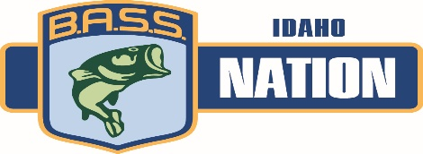
2022 Idaho BASS Nation State Championship
Qualifier Entry Form

(The BASS Clash on Coeur d’Alene)
When: June 24–25 Fri.-Sat.– Lake Coeur d’Alene, Harrison Marina
Check-in and mandatory meeting 6:00 pm June 23rd in Harrison Park - Draw 7:00 pm
This Tournament will send the top 10 Boaters and top 10 Non-Boaters to represent
the Idaho BASS Nation in the 2023 Western Regionals. No off limit period.
Added money for winners
Must be an active member of B.A.S.S., Idaho B.A.S.S. Nation and an Idaho B.A.S.S. Nation
affiliated local club. Go to www.idahobassnation.com to find a local club. Registration requires B.A.S.S. membership number and your cuurent local club paid membership.
This is a Pro Am style event. Boaters are competing against Boaters. Non-Boaters are competing against Non-Boaters. Boaters will maintain control of the boat through out the day. Pre-registration is strongly encouraged. To avoid a late fee you must sign up one week prior to the tournament (June 17th). Late entries will be accepted until 6pm PDT. Thursday, June 23rd with a $50.00 Late Fee. Signing up in Boater/Non-boater pairs is highly recommended. Boaters who do not sign up with a Non-boater will not be put into the draw to fish alone. If you are a Non-Boater and do not sign up with a Boater you are subject to Boater availability.
Mandatory Pre-tournament check-in and meeting will be from 6pm – 7pm PDT (June 23rd). Boater and Non-Boater pairings and starting positions will be done at this meeting. (If this meeting is missed you will be assigned last boat out both days) On day two the starting position will be reversed from day one and non-boaters will move one boater down.
All weights for the two-day event will be cumulative in determining the final positions. After the day two weigh-in, the top 10 Boaters and top 10 Non-Boaters will qualify for Western Regionals. First place Boater and Non-Boater will be crowned Idaho BASS Nation State Champions. The State Team will be announced at the conclusion of the weigh-in. All State Team members may be required to participate in public events to help promote the IBN and bass fishing in the State of Idaho.
Tournament Waters
Coeur d’Alene Lake and all waters accessible by boat except Blue and Anderson Lakes, including100ft from their channel entrances into the Coeur d’Alene River.

To avoid late fee entries must be received one week prior, by June 17th. Late entries will be accepted June 23rd before 6 P.M. with a $50.00 late fee. BBQ Potluck Saturday evening 5:30-7:30 at the Bertsch Residence, 29541 S Honor Rd. Harrison, ID. 83833 Participants and families welcome!

Please Return Fully Completed and Signed Form To:
Idaho BASS Nation
1760 E. Star Ln.
Meridian, ID 8364
IBN President: David Bertsch (208) 660-1937
IBN Treasurer: Chris Rambough (208) 519-9955
IBN Tournament Director: Glenn Ainsworth (541) 216-1058

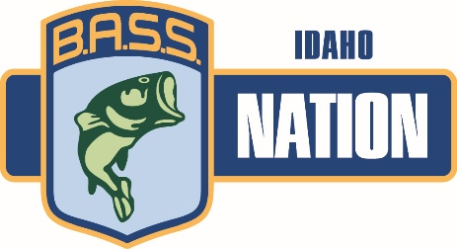
Lodging Options
Lodging on and around Lake CDA can fill up quickly in the summer as it is a vacation destination. Early reservation of lodging is encouraged. It is a great place to bring the family as well. The Coeur d’Alene Casino is on the west side of the lake but there are many boat ramps on that side of the lake that are a short boat ride to Harrison, ID.

- Home | The Corskie House B&B Harrison ID 208- 661-9989

- Lakeview Lodge Harrison Idaho, the Trail of the Coeur d'Alenes
208-689-9789

- Osprey Bed and Breakfast Harrison ID 208-689-9502

- Harrison Campground City of Harrison, ID 208-689-3393

- Rental houses VRBO - Harrison ID Vacation Rentals

- Coeur d'Alene Casino Resort Hotel 1-800-523-2464

Supporting Sponsors

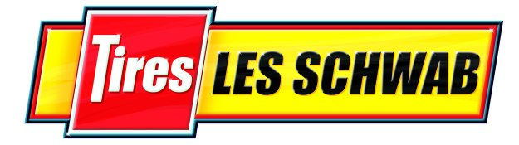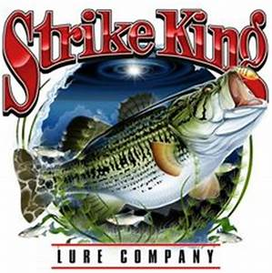

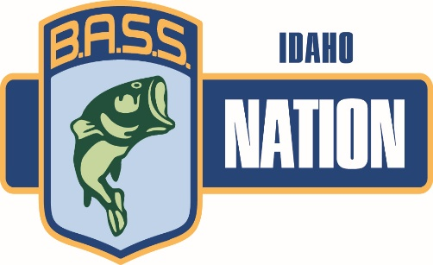
2022 Qualifier Entry Form – June 24th and 25th Lake Coeur d’Alene
*PAIRS MAY SIGN UP SEPARATELY NOTING PARTNER Entry forms and money must be received by June 17th
Boater Name __________________________ Basic Entry $300.00
Address ______________________________
E-mail _______________________________
Phone Number _________________________
Insurance Carrier _______________________
Policy No. ____________________________
B.A.S.S. Member Number ____________________
Bass Club________________________________

Total Paid _________
Non-Boater Name ______________________ Basic Entry $150.00
Address ______________________________
E-mail _______________________________
Phone Number _________________________
BASS Member Number ____________________
Bass Club _______________________________

Total Paid _________

$20.00 of each Entry is set aside for the State Regional Champion to attend Nationals.
$10 will go to the Idaho BASS Nation to run tournament.
$270 of each boater entry will go to the State Team boater travel fund. Travel funds will be paid to state team members 2 weeks prior to Regional tournament.
$120 of each non-boater entry will go to State Team non-boater travel fund. Travel funds will be paid to team members 2 weeks prior to Regional tournament.
Cash only option pots will possibly be available at the Pre-tournament meeting. (interest pending)
Possible Big Fish Pot Each Day for Boater – Non Boater (Separate Pots)
Added money for place winners

By entering the tournament, all participants release, without exception, the IBN, its owners, officers, sponsors, employees and affiliates, from liability for any accidents, loss or theft. All contestants by this signing and submitting this Entry Form agree that they have read and understood the Idaho B.A.S.S. Nation Official Tournament Rules and agree to the terms as listed. Violation of any rule will warrant appropriate disciplinary action by the Tournament Director and IBN Board of Directors.

Boater _____________________________ Date ________________

Non-Boater _______________________________ Date ________________
Signatures Required
Personal checks and money orders accepted. If your check is returned there will be a $25.00 fee If you pay cash, be sure to get a receipt.
Sponsored by the Idaho B.A.S.S. Nation

